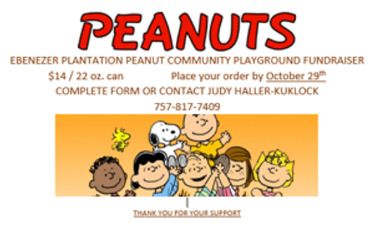
Name:____________________________________________
Phone Number:____________________________________
Please enter the number of cans for each flavor:
____Salted ____Cajun ____Jalapeno
____Unsalted ____Peanut Brittle
____Salt & Pepper ____Milk Chocolate
____Honey Roasted ____Dark Chocolate

Your order should be ready for pick up Sunday, November 19 in the
Family Life Center 9am-12:30pm
Checks made payable to EBUMC [Memo:Peanuts]

